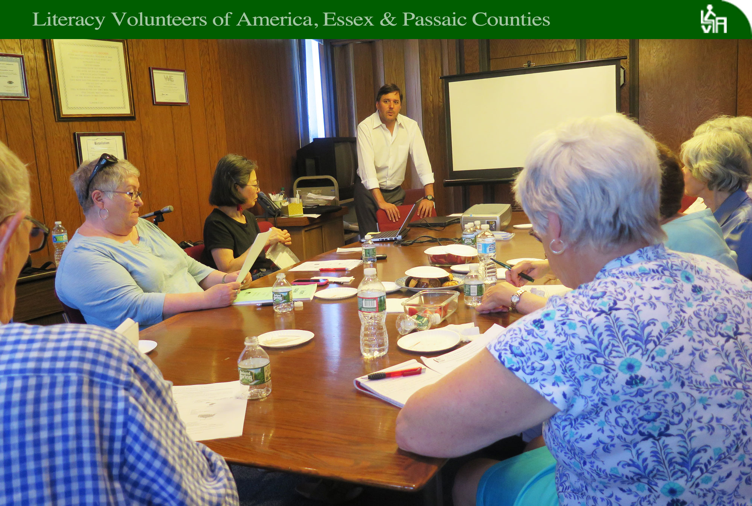

*Despite recent changes and continued underfunding, there’s still cause for hope about the state of literacy in NJ as explained by our director, Cristhian Barcelos, in a workshop last month.*

***The Insider***

Greetings LVA Family,

It was inspiring to see dozens of students from other parts of the world enroll in ESOL classes at Berkeley College in Newark, and the public libraries of Maplewood, Montclair, Passaic, and Paterson, classes organized with LVA. Many of the students cite real life experiences as their motivation to study hard in classes they often attend before and after work. “I clean houses for a living and that’s not what I want to do for the rest of my life,” said Liliana, a Colombian native who attended Grizzly Matias’s ESOL class at the Passaic Public Library. Photos of our students and teachers who completed their courses last month, appear later in this newsletter.

When it comes to the ‘State of Literacy in New Jersey,’ there is one thing that’s absolutely certain: It’s always changing. In an informative workshop last month, Cristhian Barcelos, executive director of LVA Essex & Passaic Counties, helped us understand how we’re doing in the face of recent changes to adult education programs.

We’re back at NSP. Looking forward again to training about two dozen inmates next month as tutors at Northern State Prison in Newark, men who will go on to teach basic literacy to inmates. Studies have shown that inmates have a 35-percent less chance of returning to prison if they receive literacy instruction and we’re glad to do our part, with help from volunteer inmates, to try to reduce prison recidivism.

Have a student who’s interested in becoming a citizen? Be sure to recommend that they attend the naturalization seminar, a conversation on “How to Become a U.S. Citizen,” next month at the Bloomfield Public Library. Details on Page 2.

*In the News*

To view the following stories, copy and paste the highlighted website into an internet search bar.

**‘Literacy must be a part of workforce development,’** The Buffalo News. **http://ow.ly/3WVK30dwsjX**

**‘A long overdue civil right to literacy,’** The Baltimore Sun**,** [**http://tiny.cc/9djcmy**](http://tiny.cc/9djcmy)

**‘Only two NJ towns have no immigrants,’ (w/ ‘Melting Pot’ map),** New Jersey 101.5 [**http://tiny.cc/sojcmy**](http://tiny.cc/sojcmy)

**‘The 125 nations where NJ immigrants come from – and where in NJ they live now,’** New Jersey 101.5 [**http://tinyurl.com/y7dcwda8**](http://tinyurl.com/y7dcwda8)

*The Insider,* the monthly newsletter of LVA Essex & Passaic Counties, will keep you in the loop on all of the organization’s upcoming events.

**Literacy Volunteers of America Essex & Passaic Counties**

90 Broad Street, 2nd Floor, Bloomfield, NJ 07003

(973) 566-6200, ext. 217 or 225

195 Gregory Avenue, 2nd Floor, Passaic, NJ 07055

(973) 470-0039

Cristhian Barcelos -*Executive Director*

[*cbarcelos@lvaep.org*](mailto:cbarcelos@lvaep.org)

Russell Ben Ali -*Recruitment & Training Coordinator*

[*rbenali@lvaep.org*](mailto:rbenali@lvaep.org)

Jorge Chavez -*Data Processing Coordinator*

[*jchavez@lvaep.org*](mailto:jchavez@lvaep.org)

Debbie Graham -*Education Coordinator*

[*dgraham@lvaep.org*](mailto:dgraham@lvaep.org)

Mary O’Connor -*Trainer & Tutor Support Specialist*

[*moconnor@lvaep.org*](mailto:moconnor@lvaep.org)

Marisol Ramirez -*Student Coordinator*

[*mramirez@lvaep.org*](mailto:mramirez@lvaep.org)

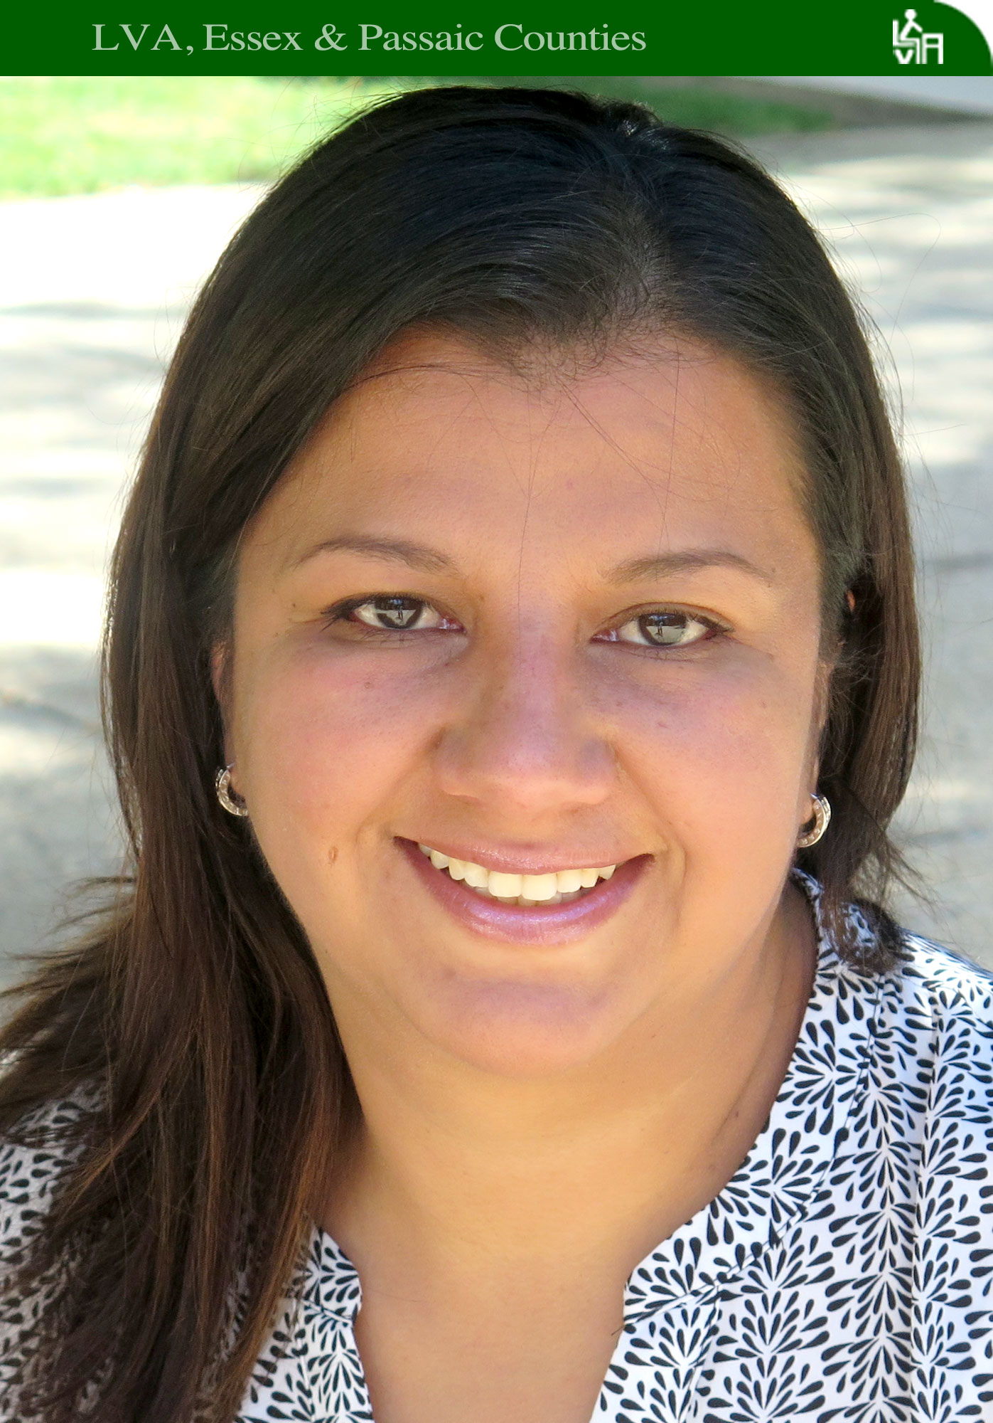

***Getting to Know Us***

**Gloria Orjuela, LVA student**

When Gloria Orjuela and her young family left their native Colombia in 2010, their first stop in North America was Canada – first to Quebec and later to Calgary. After a 6-year immigration process, it was home.

“We wanted to have a better life in Canada,” Gloria said. “My husband was traveling too much for his job in Colombia. We wanted to raise our children together and be a close family.”

Gloria left an 11-year career as a budget coordinator for one of the biggest telecom companies in Bogota, Colombia’s capital city. But, in Canada, she chose not to work, serving instead as the overseer of the family’s relocation.

While her husband worked as an electrical engineer and eldest daughter attended elementary school, Gloria stayed at home with her newborn baby girl. And while the baby napped, Gloria studied English.

By the time her infant daughter was 11 months old, Gloria’s language skills were so proficient that she was able to accept a position as an assistant teacher at her daughter’s daycare facility. At night, Gloria attended school.

She later graduated from a job-training program and, within six months, worked as an accountant, a perfect fit for Gloria, who has a bachelor’s degree with a specialization in financial management.

Her family would move again, this time to Bloomfield, after her husband found a new job in the U.S. In 2016, Gloria came to LVA where she spends at least 16 hours per month with tutors, helps coordinate LVA’s English-Spanish Language Exchange, and volunteers seven hours per week in our office at the Bloomfield Public Library. In volunteering, she said, she’s found a way to give back to the community. It hasn’t hurt her English either, which she speaks extremely well.

Gloria and her family have transitioned well into life in Essex County. “My husband is happy here, my oldest daughter is happy with her school and her new friends, and my little one is very outgoing and likes to meet new people,” Gloria said. “I think here we will find good opportunities as a family. For now, I think my road is a little bit narrow, but I am on the right track to find a job as an accountant.”

*Gloria Orjuela is an outstanding ESOL student, an office volunteer, and a coordinator of LVA’s English-Spanish Language Exchange. She learns, in part, by volunteering.*

**Tutor Training Workshops**

Bloomfield Public Library -by Nina Peyser

90 Broad Street, 2nd Floor Boardroom

Bloomfield, NJ 07003

Tuesdays and Thursdays, 12:00-3:00 pm

September 7, 12, 14, 19, 26, & 28, 2017

Montclair Public Library -by Mary Kao

50 South Fullerton Avenue

Montclair, NJ 07042

Saturdays, 12:15-3:45 pm

October 7, 14, 21, 28, & November 4, 2017

**Other Workshops and Seminars**

A conversation about “How to Become a U.S. Citizen”

U.S. Citizenship and Immigration Services (USCIS) invites you to join the conversation. Learn about the naturalization process and what you need to become a U.S. citizen.

Bloomfield Public Library

90 Broad Street, Bloomfield, NJ 07003

Monday, August 7, 2017

5:30-7:30 pm

Free and open to the public

***Literacy opens a wide door to life. Help us keep that door open with your donation!***

*Thanks in large part to you, we are able to aid hundreds of students each year. Please continue your efforts to improve the lives of others by giving the gift of literacy. You can contribute through our website* – <http://www.lvanewark.org/donatetolva/> *or by mailing us a check.*

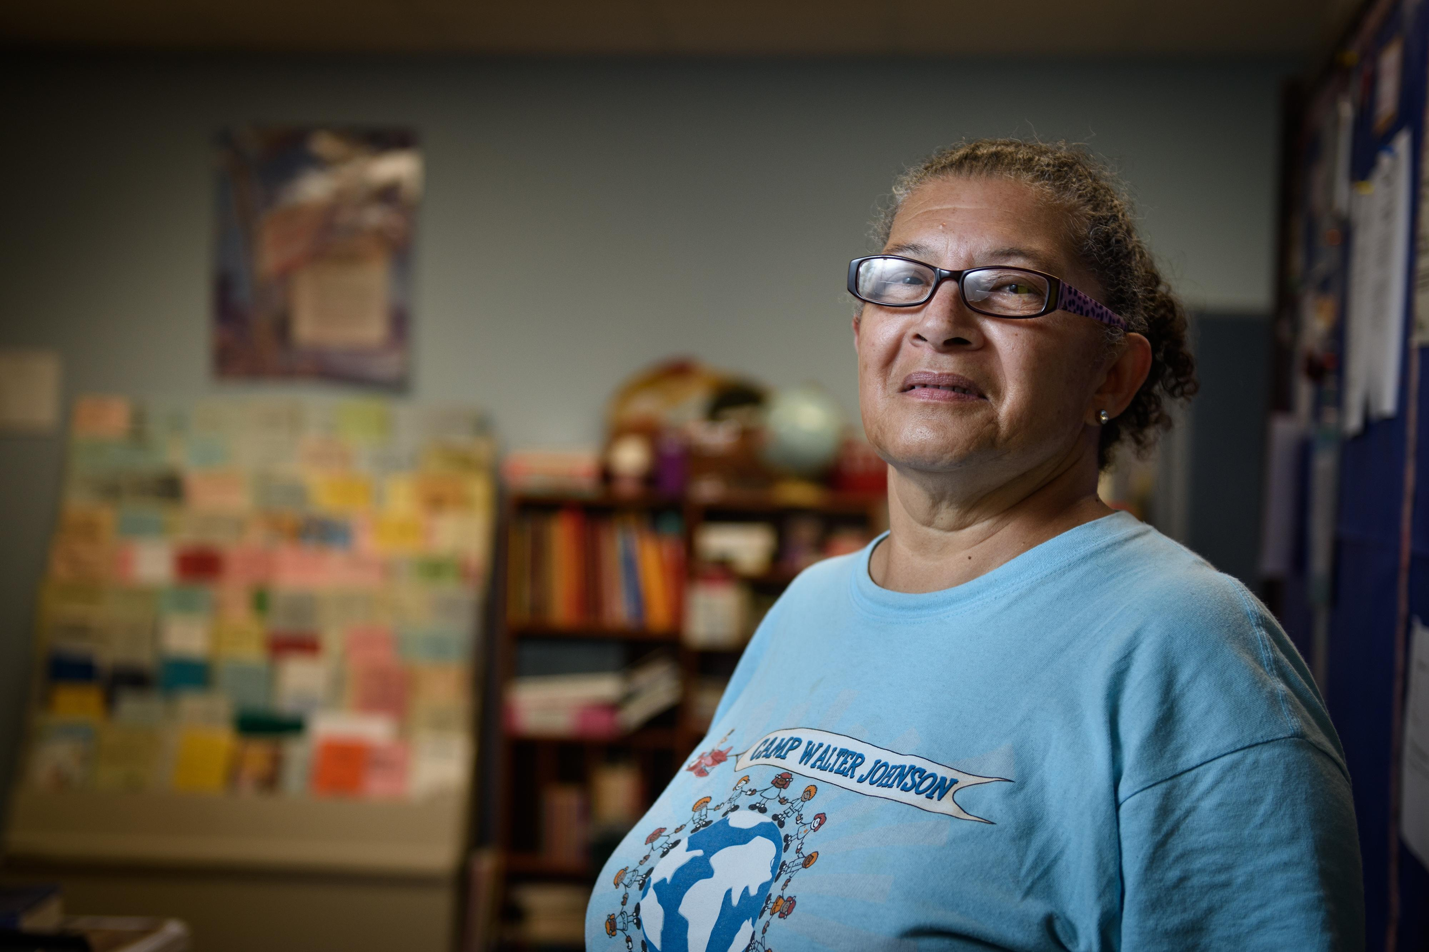

**“Senior Tutor Making a difference at 67,”**

*Fayetteville Observer*

##### By Michael Futch, April 5, 2017

Puerto Rican by birth, Wilma Hernandez was 12 years old before she started to speak English.

Now 67 and retired, she’s teaching English as a second language to a crop of Spanish-speaking students in the Fayetteville Urban Ministry Adult Literacy program. Hernandez has been volunteering her time there as a senior tutor for the last four years.

In part, Hernandez said, she does it as “sort of an homage” to her father, who decided to come to New York from Puerto Rico at the age of 35 without knowing a lick of English. Leaving the rest of his family behind, he landed work in an electrical wiring factory and improved his lot by learning how to speak, read and write English.

“The first thing he said to me when I first came to New York — my Dad had not seen me in three or four years — he said, ‘You’re going to school to learn English because you’re not working in a factory,’” she recalled from her teaching cubicle inside the Urban Ministry building off Whitfield Street. “He said, ‘I work in a factory, and I’m getting out of the factory.’ And he did. He said, ‘You’re going to live a lot better. I want you to be a professional and sit at a desk. That’s the kind of job that I want you to do.’ Everybody had to have a high school diploma. We all had to graduate from high school.”

Hernandez is instilling that same necessity to learn the English language in nine students who originate from El Salvador, Santo Domingo, Korea and Myanmar. She is expected to soon pick up a few more students. In their native countries, she noted, they are all professionals from different vocations.

*Reprinted from the Fayetteville Observer. For full story, paste the following link into an Internet search:* [**http://tiny.cc/x6icmy**](http://tiny.cc/x6icmy)

***Getting to Know Us (cont.)***

**Sue Slater, LVA tutor**

Back in November 2015, Sue Slater decided to attend a civic showcase, an event where local organizations, clubs, and institutions show what services and activities they offer to members. Her life has not been the same since. She left the showcase at Bloomfield High School with a new church and church family, and a volunteer tutor position she would devote her days to.

“After retiring from work, I needed something meaningful to do with my life,” she said. “I heard about Literacy Volunteers of America when I was working and found that this might be something I wanted to explore. I knew that I did not want to spend my retirement floating and doing nothing.”

Sue has now been a tutor with LVA for almost a year and a half. A former accountant and self-proclaimed introvert, Sue is comfortable with her group of four ESOL students and eagerly welcomes more to add to her roster. When asked how she sees herself now, Sue said, "I feel great. When I first started tutoring my self- confidence and my ability to do new things was on the fence. I shortly found out I was able to shift gears. I feel very confident and very comfortable.”

Sue's students have all made great strides and she attributes their success to hard work on their part. Although, listening to her somewhat lively group at the Bloomfield Library, one might wonder if is a social get together.

That’s because Sue likes to keep her lessons both educational and fun. "The very first time I tutored, I thought I had ample material,” she said. "Boy was I wrong. I now have more material than I need. I incorporate icebreakers, bingo, and Bananagrams into my tutoring. I like a variety of things to do and try to make lessons into a game form to make them more interesting.”

When Sue is not tutoring, she treasures her spiritual family with whom she spends time at the Brookdale Reformed Church in Bloomfield. A bit ironic for Sue, a self-described “church dropout for 35 years,” who now calls the church home. “I met a woman at church who has turned out to be a very special friend,” Sue said. "Neither of us grew up with sisters, so now we call each other the sister we never had. We laugh, we cry, we are a family.”

*Learning a new culture is more than studying a language. Tutoring is more than learning techniques. Our ‘Resources’ page covers everything from legal matters, health care, & scholarships for immigrants, to professional development for tutors. Give us a look @:*

[***http://www.lvaep.org/students.html***](http://www.lvaep.org/students.html)

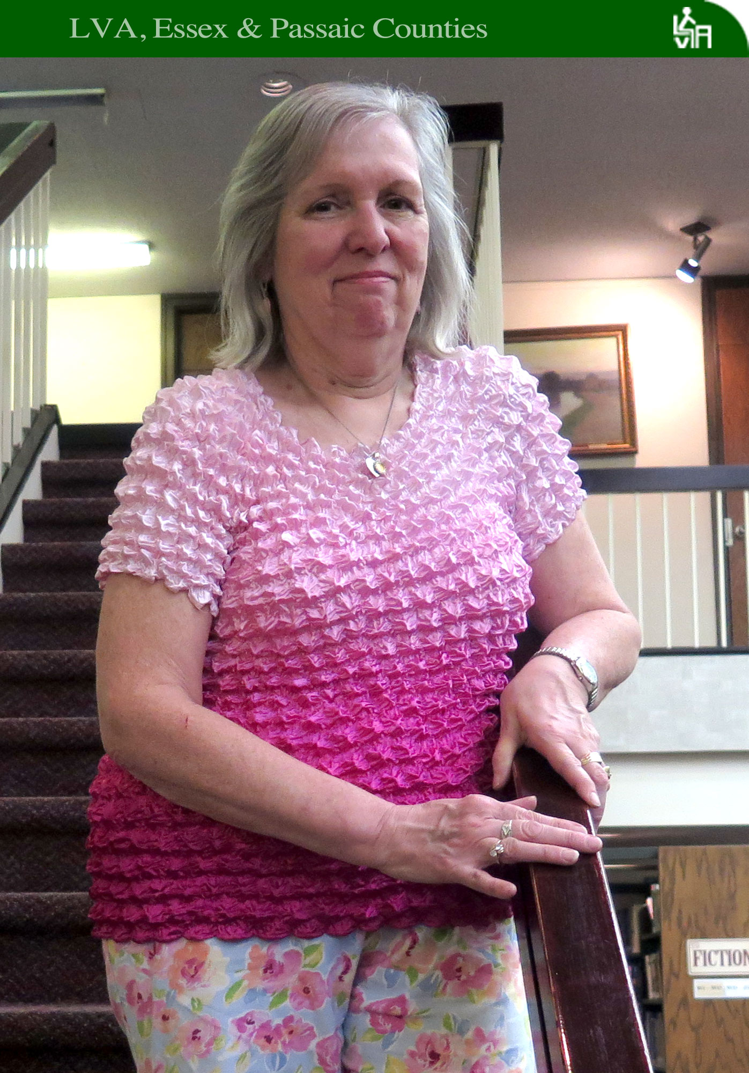

***Adult Literacy & Community Library Partnership Pilot Program***

*It’s often a simple accomplishment when navigating a new language that can feel like a triumph to a student and bring a sudden wave of encouragement. For Camila, an ESOL student from Colombia and a working parent, success came on the job and she rushed to recall the experience to her teacher, Jalisa Harris, in her class at the Paterson Public Library. “Teacher, I am speaking to my boss more!” Camila said.*

*Camila’s class was offered through the Adult Literacy and Community Library Partnership, a state pilot grant program that aims to create direct partnerships between local libraries and adult literacy service providers. Together, libraries and literacy organizations provide training or language instruction that help New Jersey residents increase their Adult Basic Education and language proficiency skills in order to enhance their chances of finding employment outside of the low-skilled job market. Funds were granted to 11 libraries throughout the state, including Maplewood, Montclair, Passaic, and Paterson, which work with LVA to offer intensive ESL classes. The program is now in its second year and new classes began this week in Maplewood, Passaic, and Paterson.*

*“When I came from Turkey, I couldn’t understand anyone,” said Sema, a student in Grizzly Matias’s class at the Passaic Public Library who advanced from a beginner to an intermediate-level class. “It was very frustrating and I knew I had to do something about it,” she said. Sema hopes to one day become an English teacher.*

*Saleh, a 19-year-old student at a Passaic Public Library class, was badly injured in a bombing while playing soccer with friends in war-torn Syria. Three other boys were killed in the bombing. Saleh spent six months in a Turkish hospital, recovering from injuries and undergoing surgeries. He speaks Arabic, Turkish, and Kurdish. “Saleh will undergo another surgery here in the U.S. but, in the meantime, he is hard at work learning English,” said his teacher, Susan Bogda.*

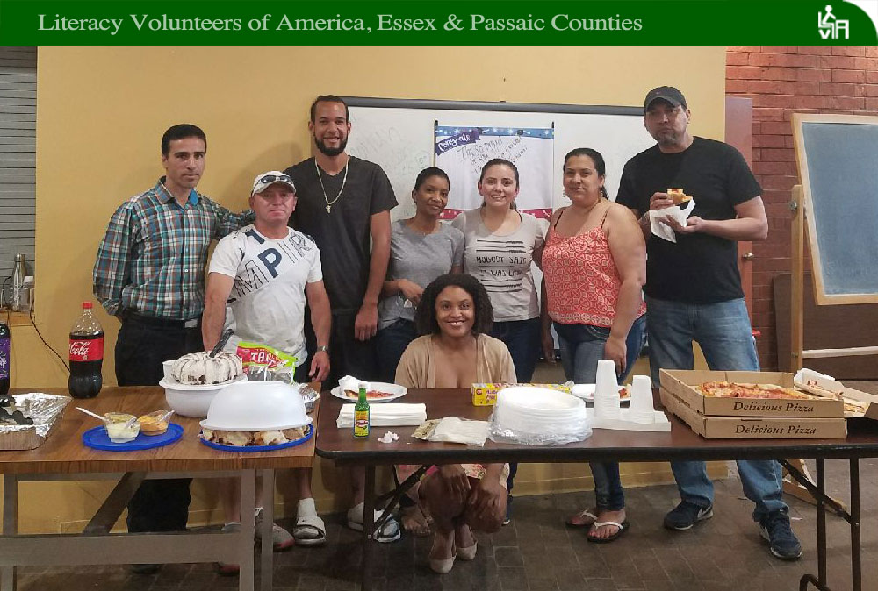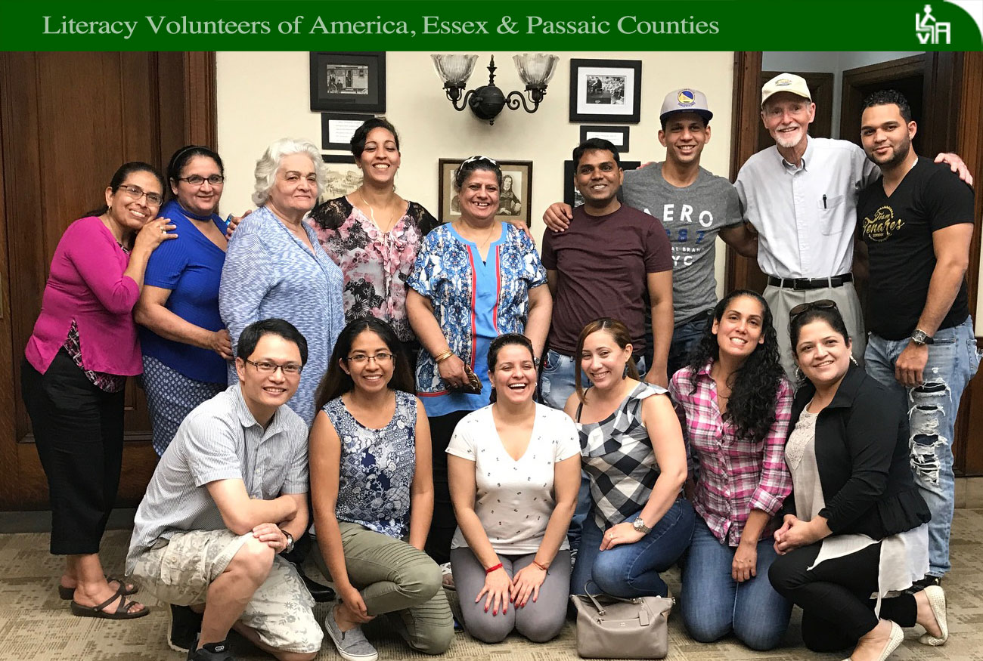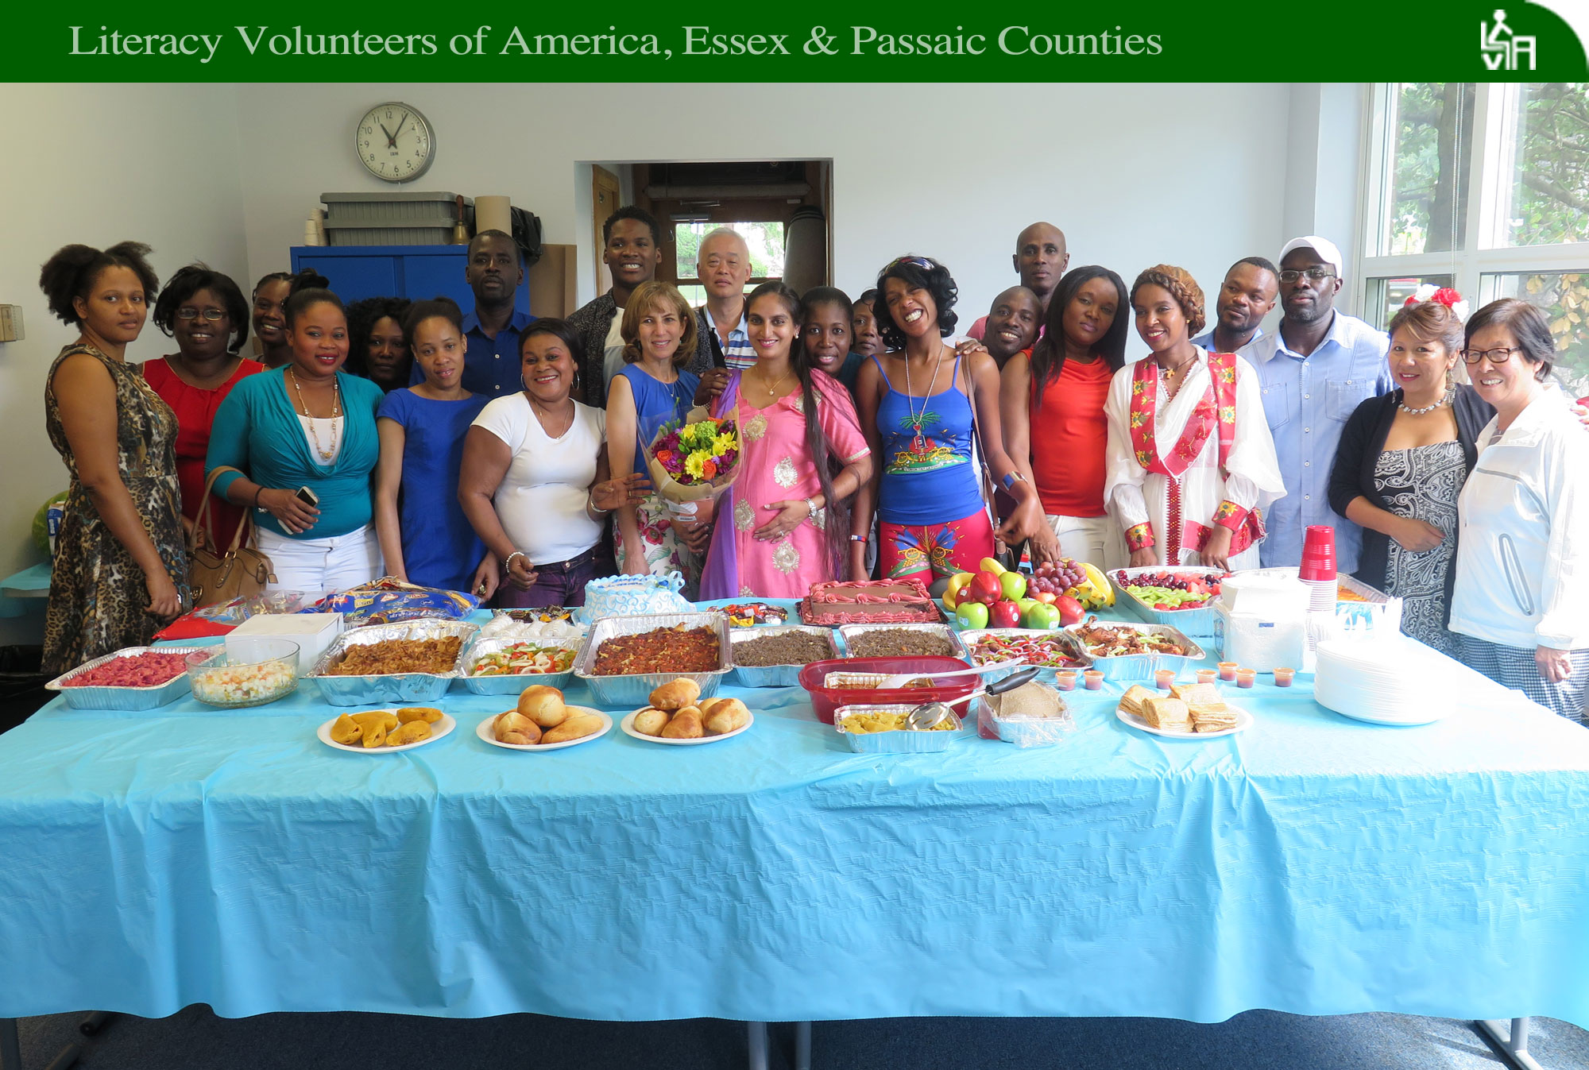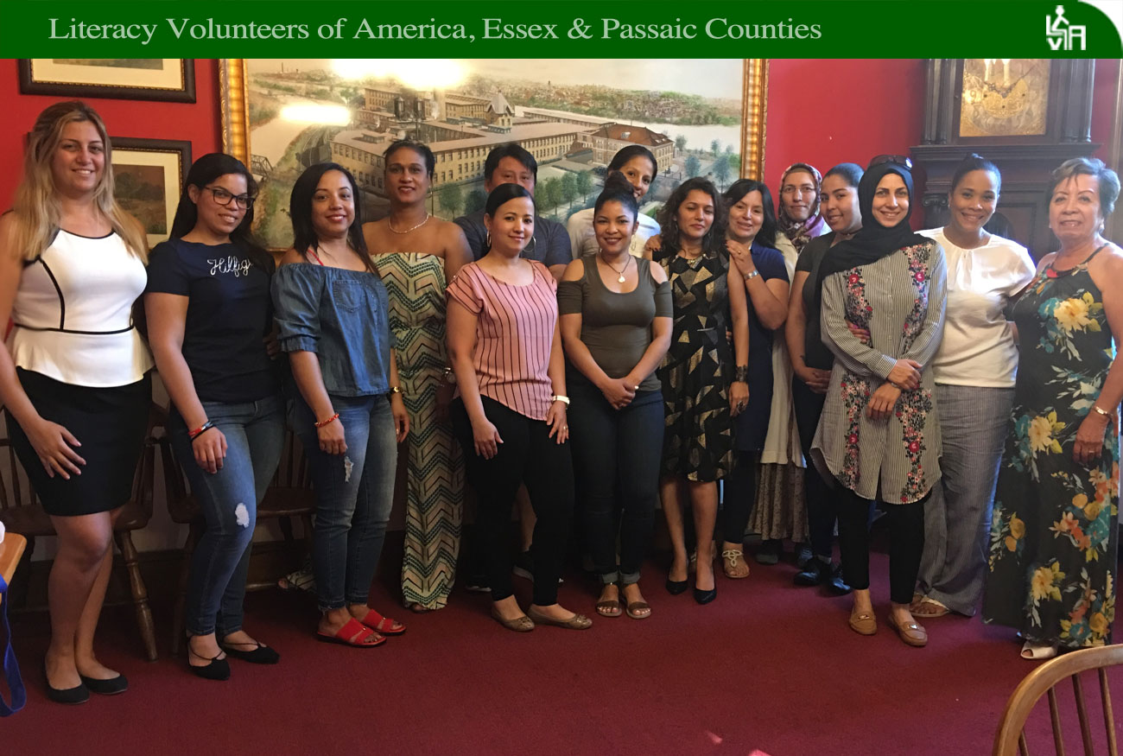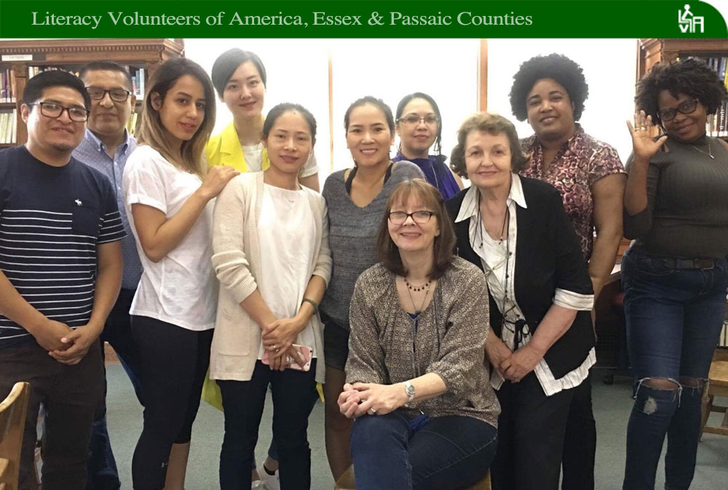

***Adult Literacy & Community Library Partnership Pilot Program***

*For 10 weeks, students attended ESOL classes at Berkeley College in Newark, in a joint pilot program run by the school, the Sussex Educational Foundation, and Literacy Volunteers of America, Essex & Passaic Counties. Dozens of students completed classes last month in three levels – beginner, intermediate, and advanced. Here’s a snapshot of several students:*

*Marie holds a degree in economics from Haiti. In the U.S. she was afraid to be alone in public. “I couldn’t even ask someone for directions if I was lost,” she said. At times, she said, her inability to communicate left her feeling like a two-year-old. Despite her discomfort, Marie attended evening classes at Berkeley while 29-weeks pregnant with twins. “Without realizing it, Marie found herself on several occasions thinking in English,” said her teacher, Roxanne Peterson. “For her, this was a huge accomplishment.”*

*Arelis, a native of the Dominican Republic with three children, moved to the U.S. to seek better medical attention for her husband, who was left unable to walk after a long time in a coma. “She realized that learning a new language wouldn’t be easy but her husband told her, ‘If you want to do something, you have to suffer a little bit,’ ” said Roxanne Peterson, Arelis’s teacher.*

*Cindy, another student from the Dominican Republic, started a new job several months ago and it hasn’t been easy. “My first week on the job was terrible because I couldn’t understand my boss,” she said, adding that there were times she gave him the impression that she understood him, when she didn’t. She comes to class with plenty of questions about to how respond to customers at her job, said her teacher, Darnelle Richardson. “Cindy is very motivated to learn, and she learns quickly,” Darnelle said.*

